Zombie Mix

*serving size: 20*

You will need:

 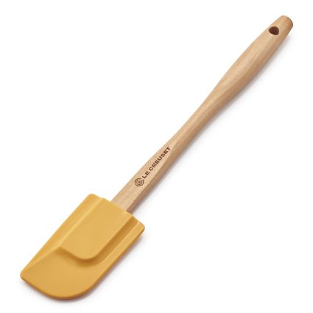 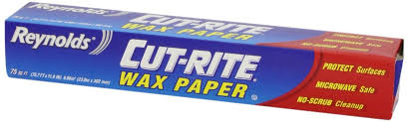  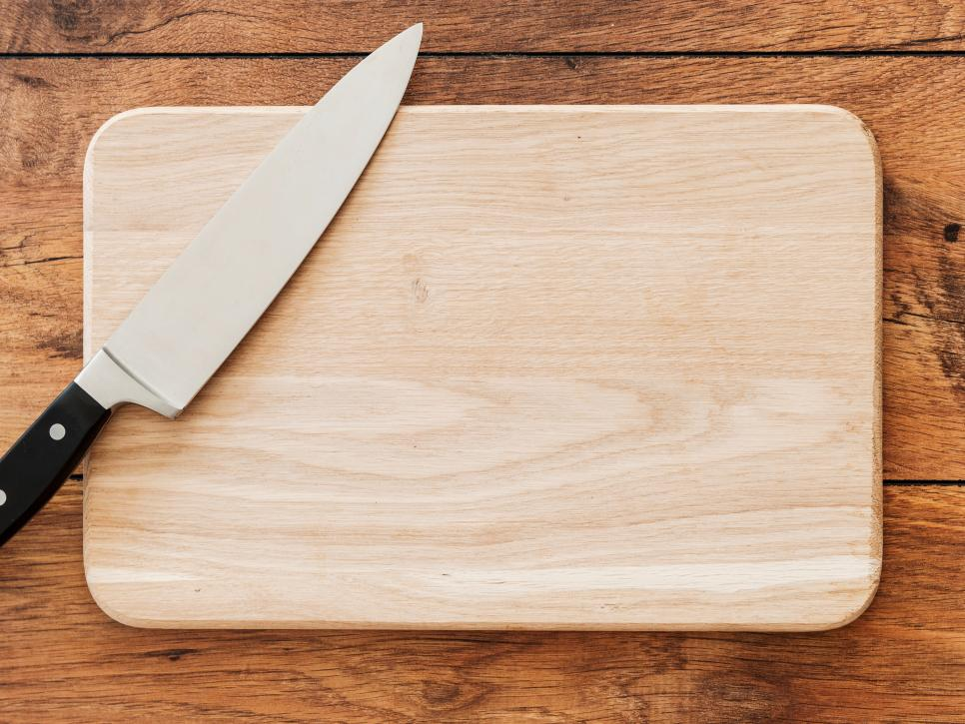

Lg. mixing bowls spatula wax paper spoon cutting board & knife

spoon

4 c. of vanilla Chex cereal

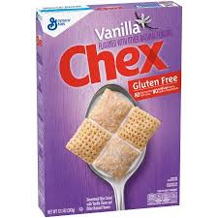

4 c. of cinnamon Chex cereal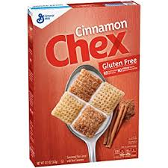

1 ½ c. of candy corn

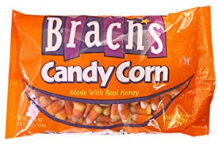

2 c. chopped Halloween chocolate candy

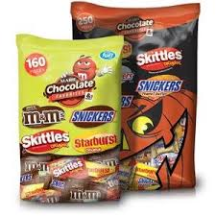

Submitted by: Katrina H.

Directions

1. In very large bowl, mix cereals.
2. Add chopped chocolate candies and candy corn into cereal mixture.
3. Combine the cereal and candies.
4. Spread mixture evenly on waxed paper.
5. Separately melt orange and chocolate candy melts according to packaging I microwave safe bowls.
6. Stir 1 tbsp. of vegetable oil into each bowl of melted candy.
7. Drizzle melted candies onto cereal and candy mix.
8. Let cool and set for ~30-45 minutes.



Ingredients

1 c. orange candy melts

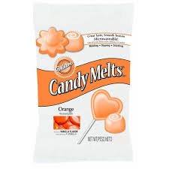

1 c. chocolate candy melts



sprinkles

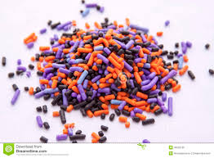

2 tbs. of vegetable oil

